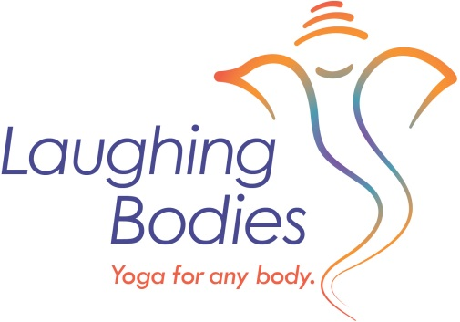 Laughing Bodies Teacher Training Application Form:
You may wonder why – an application? Teacher Training/Yoga Immersion is a big commitment. It’s important to make sure this program is right for you. There are two tracks for this training – one to become a teacher and one for those who want to study and learn more about yoga. You can decide at any point to go for the teaching RYS certification or stick with the Immersion. Many folks don’t decide until they are near the end of the training.
Name;
Full mailing Address
DOB:
Cell number:
Home Number:
Email address::
(Feel free to attach additional pages to answer these questions).
- What is your background and experience with yoga?

- How many years have you been practicing?

- Are you a teacher now and if so where?

- List teachers you have worked and studied with?

- Do you have a meditation practice?

- Do you have a home practice and if so please describe?

- Do have any special medical concerns?

- What is you educational and professional background?

- What brings you joy?

- Why do you want to take this training or why are you considering?

- Do you have any questions for me.

When finished, please save the file and email to Rebecca@laughingbodies.com.
I will be in touch to connect by phone or Skype.
If you have any questions while filling out this form feel free to email or call 760 484 4390.
Blessings,
Rebecca Dennis

