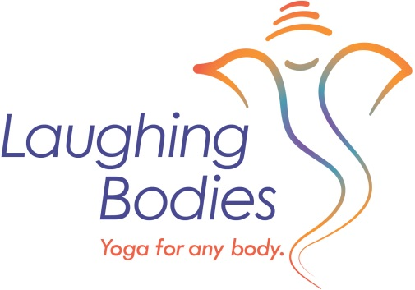
The full fee for TT/Yoga Immersion 2019 includes 4 months of on line training and 8 twenty hour weekends. The fee is between $2695-$2850.
Payment plans are available and can be made online through PayPal or by check.

Option 1: $2695: Pay full amount in one payment by December 15th, 2019
Option 2: $2850: $600 deposit by December 15th, 2019
Payment plan is $450 per month beginning Jan. 1st, 2020 for five months.

